7.Write a Pandas program to create a Pivot table and find the maximum and minimum
sale value of the items.

Code:
import pandas as pd
sales = pd.read_csv("sales_data.csv")
pivot_table = pd.pivot_table(
sales,
values="Sale_Value",
index="Item",
aggfunc=["max", "min"]
)
print(pivot_table)

Output:
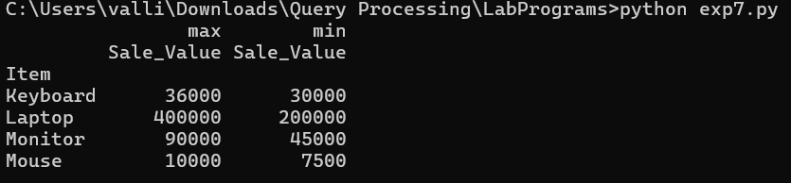

8.Write a Pandas program to create a Pivot table and find the item wise unit sold.

Code:
import pandas as pd
sales = pd.read_csv("sales_data.csv")
pivot_table = pd.pivot_table(
sales,
values="Unit_Sold",
index="Item",
aggfunc="sum"
)
print(pivot_table)

Output:
